**OPERATING SYSTEMS**

**ASSIGNMENT-14**

**NAME: - MUTTA DATTA SAI VISHNU MOHAN  
USN: - 22BTRAD026**

**#LINUX TERMINAL**

**Linux Commands**

1.  pwd Command

**The pwd command stands for “print working directory,” and it outputs the absolute path of the directory you’re in. For example, if your username is “Aurobindo” and you’re in your Documents directory, its absolute path would be: /home/Aurobindo/Documents.**

**To use it, simply type pwd in the terminal:**

**Pwd**

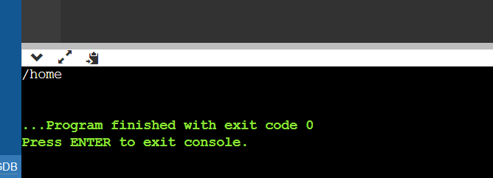

2.  cd Command

**The cd command refers to “change directory” and, as its name suggests, switches you to the directory you’re trying to access.**

1. **mkdir Command: The**[**mkdir**](https://www.javatpoint.com/linux-mkdir)**command is used to create a new directory under any directory.**

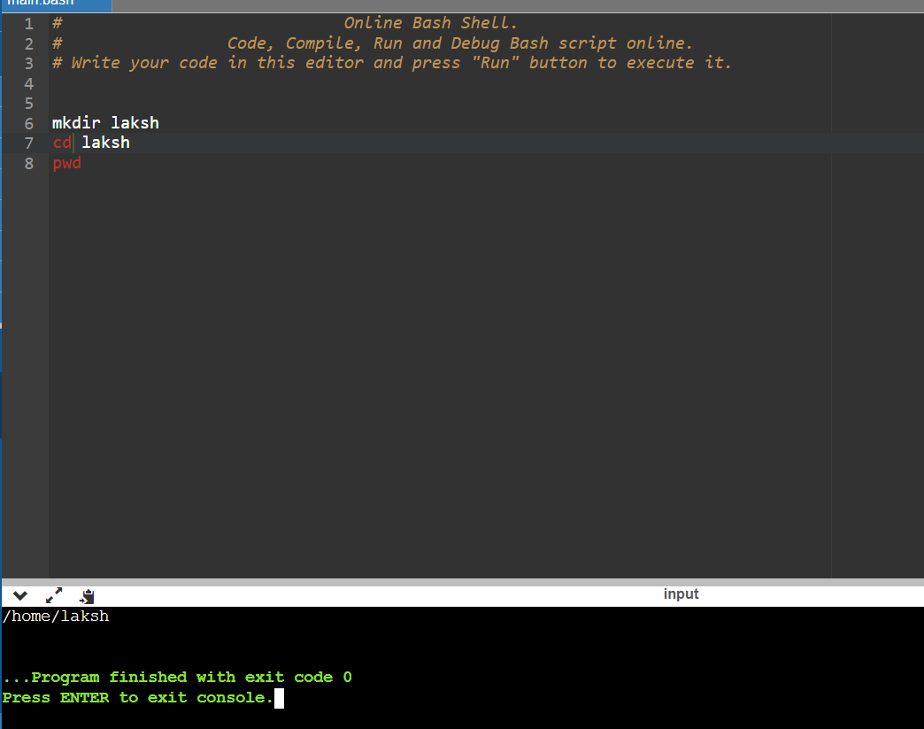

1. **rmdir Command: The**[**rmdir**](https://www.javatpoint.com/linux-rmdir)**command is used to delete a directory.**

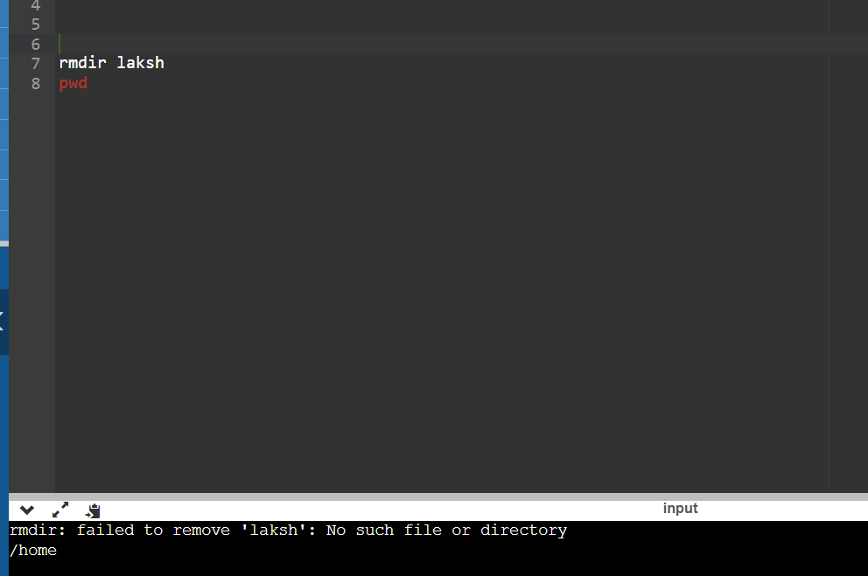

1. **ls Command: The**[**ls**](https://www.javatpoint.com/linux-ls)**command is used to display a list of content of a directory.**

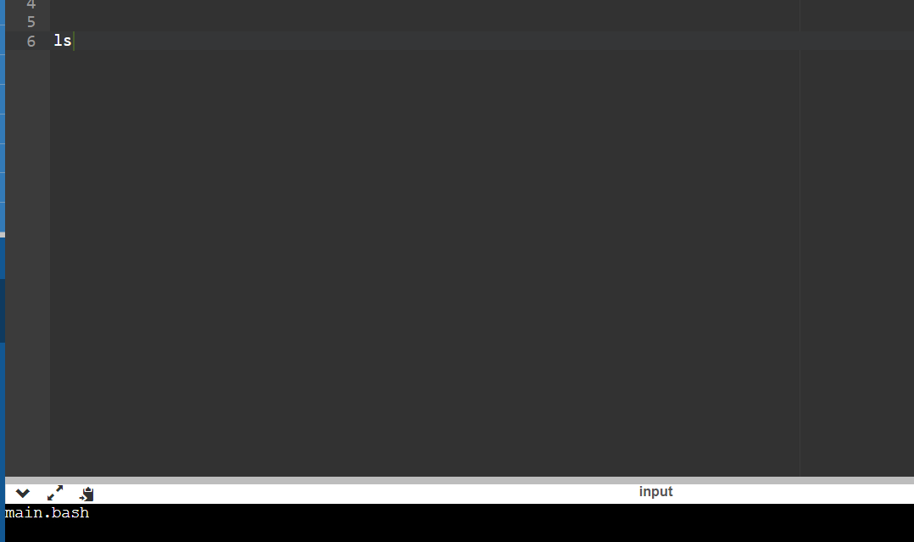

1. **touch Command: The**[**touch**](https://www.javatpoint.com/linux-touch)**command is used to create empty files. We can create multiple empty files by executing it once.**

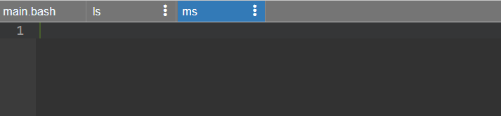

1. **cat Command: The**[**cat**](https://www.javatpoint.com/linux-cat)**command is a multi-purpose utility in the Linux system. It can be used to create a file, display content of the file, copy the content of one file to another file, and more.**

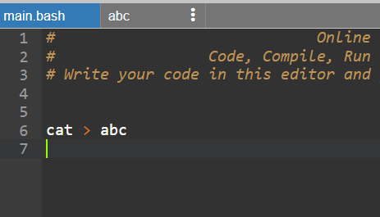

1. **rm Command: The**[**rm**](https://www.javatpoint.com/linux-rm)**command is used to remove a file.**

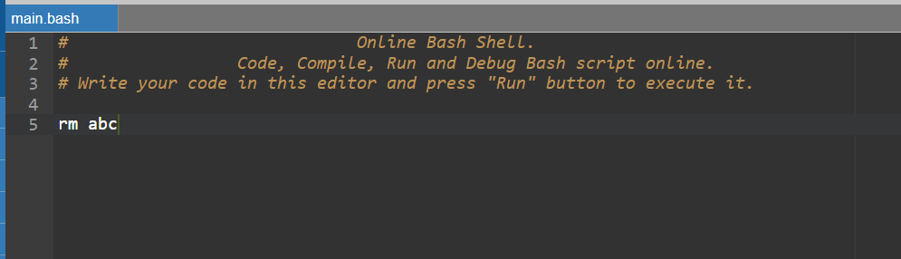

10.rm Command: rm command to remove files and directories.

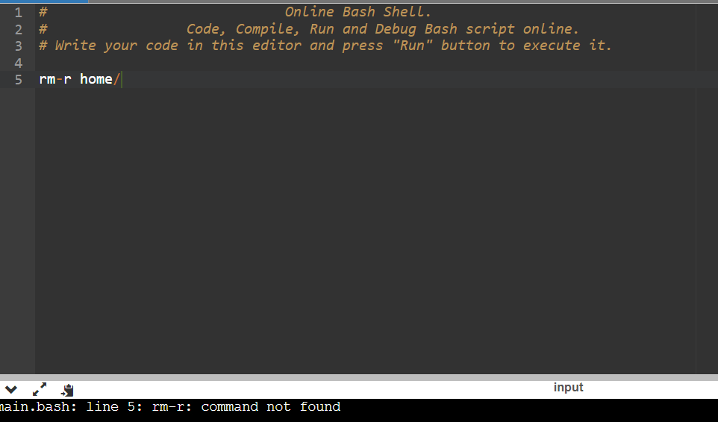11. mv Command: mv command to move (or rename) files and directories through your file system.

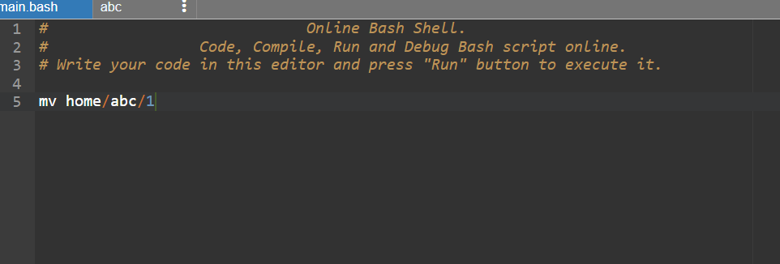

12.mkdir Command: To create folders in the shell, you use the mkdir command. Just specify the new folder’s name, ensure it doesn’t exist, and you’re ready to go.

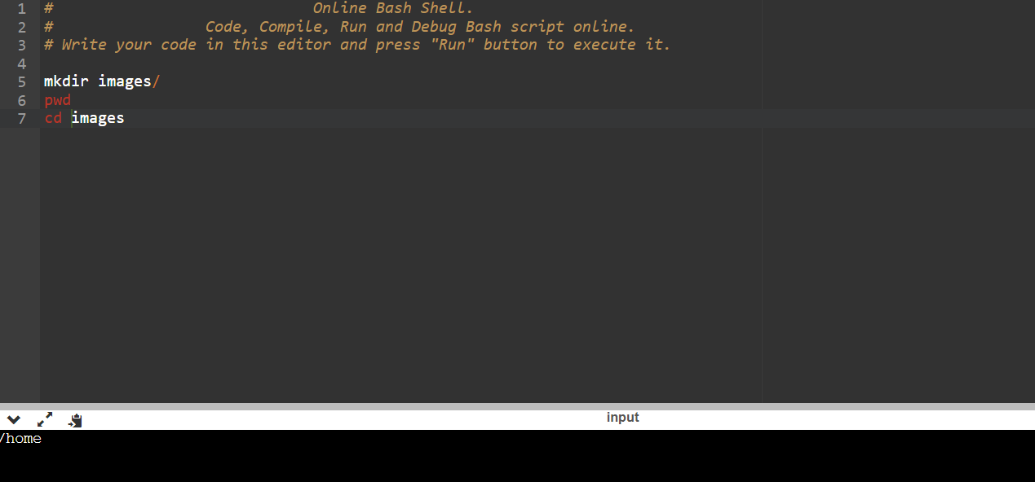13.man Command

**It displays the manual page of any other command (as long as it has one).**

